Week – 0 Algorithm and Flowchart

Name:Vijay S
Roll no.: 241801313

Calculate Area and Perimeter

Q1)Write an algorithm and draw a flow chart to calculate the area and perimeter of a square
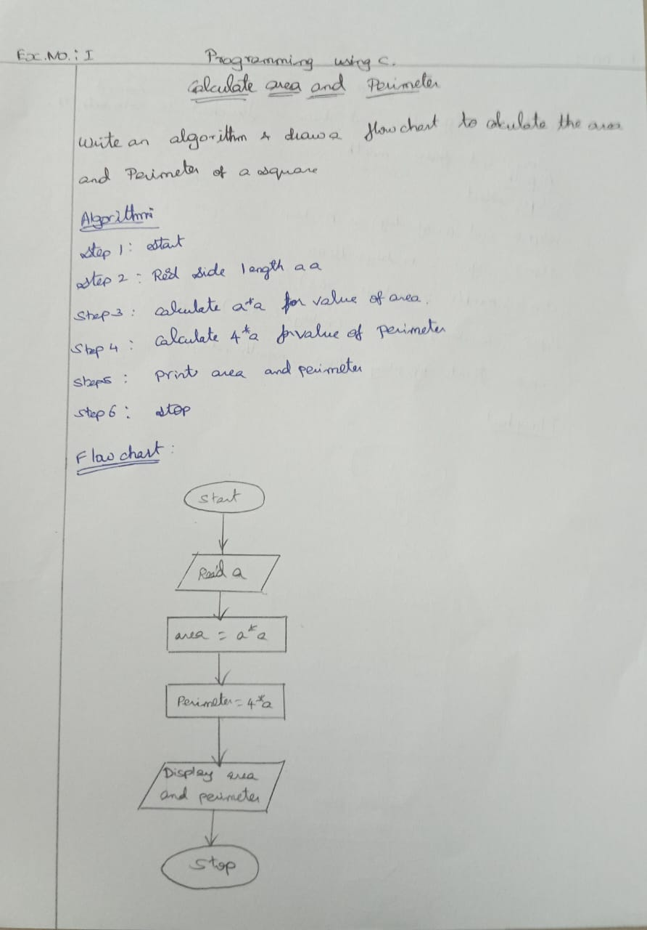

Days to year Conversion

Q2) Write an algorithm and draw a flow chart to Convert the days into years , months
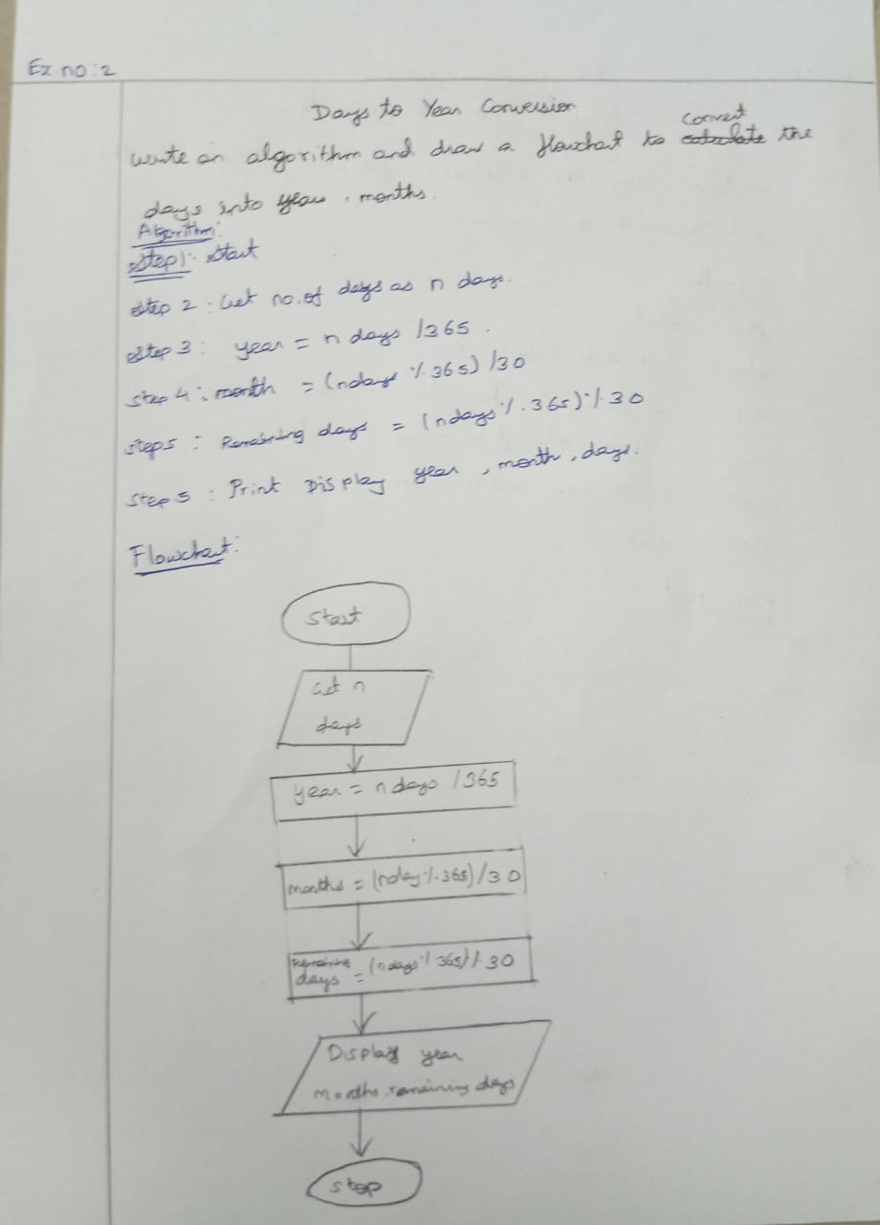

Prime Number

Q3) Write an algorithm and draw a flow chart to check the given number is prime or not

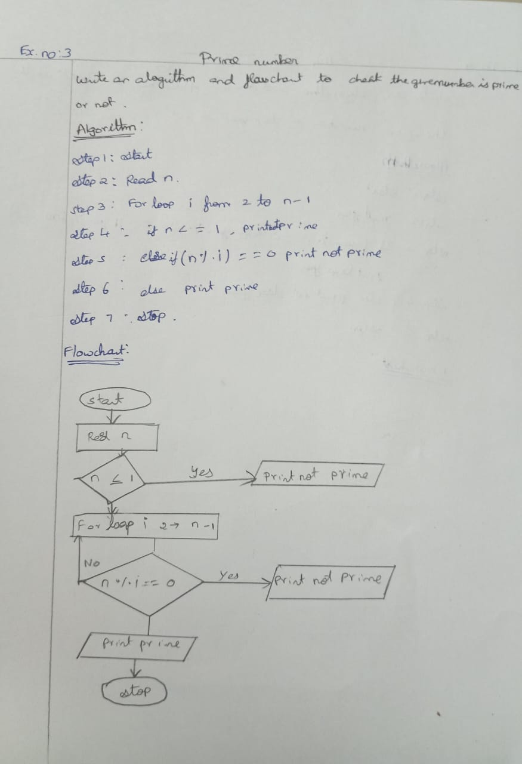

Leap Year

Q4) Write an algorithm and draw a flow chart to check whether the given year is leap year or not.
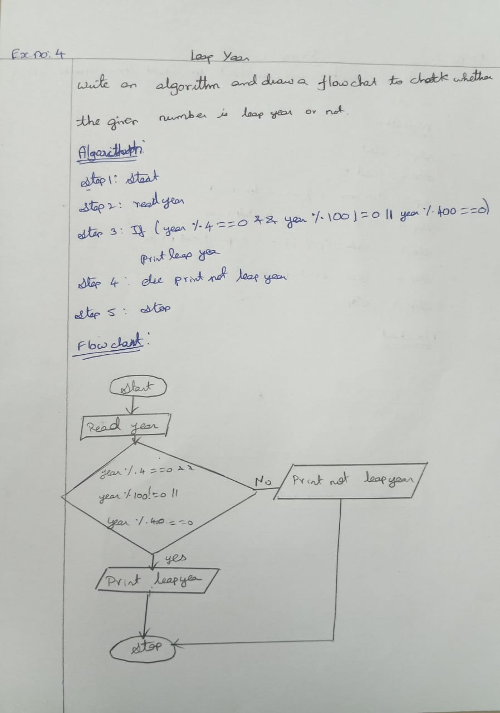

Palindrome Number
Q5) Write an algorithm and draw a flow chart to check whether the given number is palindrome number or not.
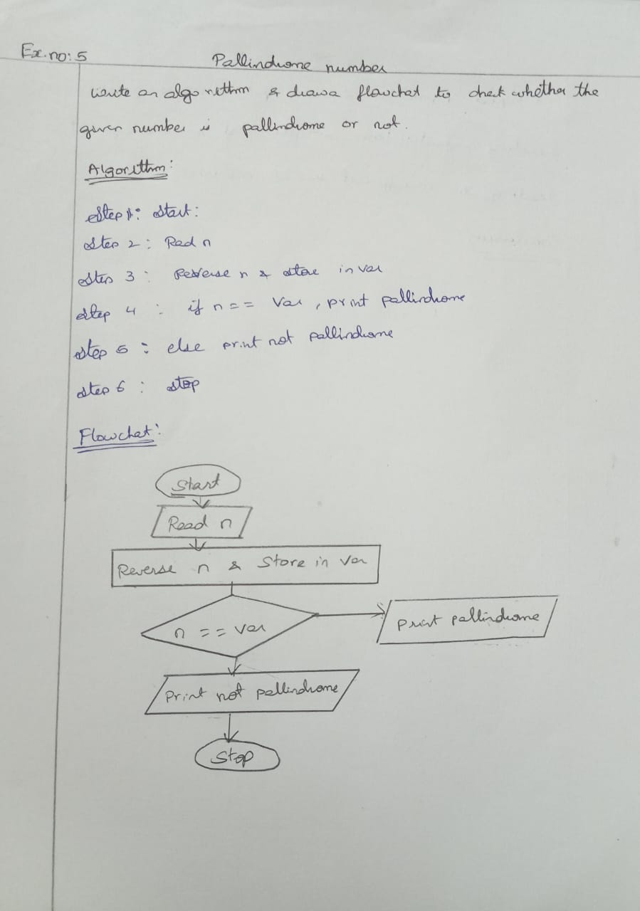

Sum of Digits
Q6) Write an algorithm and draw a flow chart to calculate the sum of digits in the given number
